**LABORATORY RECORD NOTEBOOK**

**AMITY UNIVERSITY CHHATTISGARH**

**LABORATORY MANUAL**

*A Lab Manual Submitted to*

**Amity University Chhattisgarh, Raipur (AUC)**

In

**Computer Science Engineering**

By

Niladitya Sen

(A80105222017)

*Submitted to*

**Mr Rahul Kumar Kaushik**

**Amity University Chhattisgarh, Raipur**

**Amity School of Engineering & Technology**

**Amity University Chhattisgarh, Raipur (AUC)**

**Manth / Kharora, (Opp.-ITBP) SH-09,**

**Raipur, Chhattisgarh - 493225**

**(2023-24)**

**Amity University Chhattisgarh**

**Amity School of Engineering & Technology**

**Batch: 2022- 2026**

**Enrolment Number**: A80105222017

This is to certify that this is a Bonafede record of the work done by **Niladitya Sen** bearing enrollment number **A80105222017** of **B. Tech Computer Science & Engineering** Semester **IV**, from Amity School of Engineering & Technology, Amity University Chhattisgarh in the **JAVA PROGRAMMING LAB** with Course Code **CSE3408.**

University Examination held on ______________________.

|  |  |
| --- | --- |
| Faculty In-charge | Director-ASET |

|  |
| --- |
| Examiner-1 |
| Examiner-2 |

**INDEX**

|  |  |  |  |  |
| --- | --- | --- | --- | --- |
| **Sl. No** | **Experiment** | **Date of Experiment** | **Date of Submission** | **Signature** |
|  |  |  |  |  |
|  |  |  |  |  |
|  |  |  |  |  |
|  |  |  |  |  |
|  |  |  |  |  |
|  |  |  |  |  |
|  |  |  |  |  |
|  |  |  |  |  |
|  |  |  |  |  |
|  |  |  |  |  |
|  |  |  |  |  |
|  |  |  |  |  |
|  |  |  |  |  |
|  |  |  |  |  |
|  |  |  |  |  |
|  |  |  |  |  |
|  |  |  |  |  |
|  |  |  |  |  |
|  |  |  |  |  |

**Experiment 1**

**Aim: WAP in java to enter any number and print the month of the year using switch case.**

**Solution:**

import java.util.Scanner;

public class MonthOfYear {

public static void main(String[] args) {

Scanner sc = new Scanner(System.in);

System.out.println("Enter the month number: ");

int month = sc.nextInt();

switch (month) {

case 1:

System.out.println("January");

break;

case 2:

System.out.println("Febuary");

break;

case 3:

System.out.println("March");

break;

case 4:

System.out.println("April");

break;

case 5:

System.out.println("May");

break;

case 6:

System.out.println("June");

break;

case 7:

System.out.println("July");

break;

case 8:

System.out.println("August");

break;

case 9:

System.out.println("September");

break;

case 10:

System.out.println("October");

break;

case 11:

System.out.println("November");

break;

case 12:

System.out.println("December");

break;

default:

System.out.println("Invalid month number");

}

}

}

**Output:**

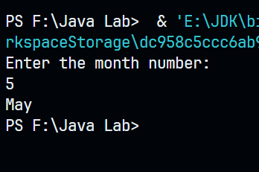

**Experiment 2**

**Aim: WAP in java to enter any age and check whether he or she is eligible for voting.**

**Solution:**

import java.util.Scanner;

public class Voting {

public static void main(String[] args) {

Scanner sc = new Scanner(System.in);

System.out.println("Enter your age: ");

int age = sc.nextInt();

if (age >= 18) {

System.out.println("You are eligible to vote");

} else {

System.out.println("You are not eligible to vote");

}

}

}

**Output:**

**Experiment 3**

**Aim: WAP in java to enter 10 nos using 1D array and print the largest and smallest number.**

**Solution:**

import java.util.Scanner;

public class MaxMin {

public static void main(String[] args) {

int[] arr = new int[10];

Scanner sc = new Scanner(System.in);

System.out.println("Enter 10 numbers: ");

for (int i = 0; i < 10; i++) {

arr[i] = sc.nextInt();

}

int max = arr[0];

int min = arr[0];

for (int i = 1; i < 10; i++) {

if (arr[i] > max) {

max = arr[i];

}

if (arr[i] < min) {

min = arr[i];

}

}

System.out.println("Largest number: " + max);

System.out.println("Smallest number: " + min);

}

}

**Output:**

**Experiment 4**

**Aim: WAP in java to enter 1 to 20 numbers using 1D array and print even numbers only.**

**Solution:**

public class EvenNos {

public static void main(String[] args) {

int[] arr = new int[20];

for (int i = 0; i < 20; i++) {

arr[i] = i + 1;

}

for (int i = 0; i < 20; i++) {

if (arr[i] % 2 == 0) {

System.out.println(arr[i]);

}

}

}

}

**Output:**

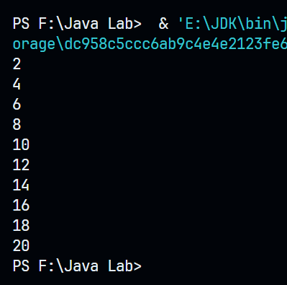

**Experiment 5**

**Aim: WAP in java to enter 2 matrices using 2D array and find the sum of both the matrices.**

**Solution:**

import java.util.Scanner;

public class AddMatrices {

public static void main(String[] args) {

int[][] a = new int[3][3];

int[][] b = new int[3][3];

Scanner sc = new Scanner(System.in);

System.out.println("Enter the elements of the first matrix: ");

for (int i = 0; i < 3; i++) {

for (int j = 0; j < 3; j++) {

a[i][j] = sc.nextInt();

}

}

System.out.println("Enter the elements of the second matrix: ");

for (int i = 0; i < 3; i++) {

for (int j = 0; j < 3; j++) {

b[i][j] = sc.nextInt();

}

}

int[][] sum = new int[3][3];

for (int i = 0; i < 3; i++) {

for (int j = 0; j < 3; j++) {

sum[i][j] = a[i][j] + b[i][j];

}

}

System.out.println("The sum of the two matrices is: ");

for (int i = 0; i < 3; i++) {

for (int j = 0; j < 3; j++) {

System.out.print(sum[i][j] + " ");

}

System.out.println();

}

}

}

**Output:**

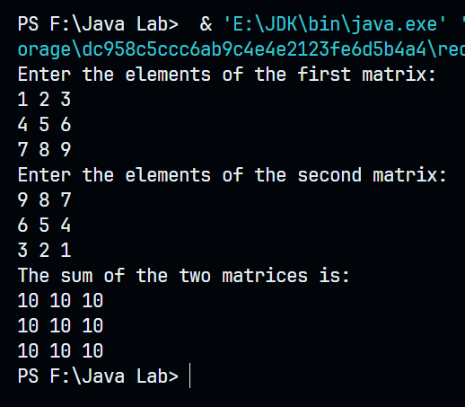

**Experiment 6**

**Aim: WAP in java to print multiplication table of 5 using while loop.**

**Solution:**

public class TableOf5 {

public static void main(String[] args) {

int i = 1;

while (i <= 10) {

System.out.println("5 * " + i + " = " + 5 * i);

i++;

}

}

}

**Output:**

**Experiment 7**

**Aim: WAP in java to enter employee salary and bonus and display it using single inheritance.**

**Solution:**

import java.util.Scanner;

class Salary {

int salary;

int bonus;

Scanner sc = new Scanner(System.in);

void getSalary() {

System.out.print("Enter the salary: ");

salary = sc.nextInt();

}

void getBonus() {

System.out.print("Enter the bonus: ");

bonus = sc.nextInt();

}

void display() {

System.out.println("Salary: " + salary);

System.out.println("Bonus: " + bonus);

}

}

public class Employee extends Salary {

public static void main(String[] args) {

Employee emp = new Employee();

emp.getSalary();

emp.getBonus();

emp.display();

}

}

**Output:**

**Experiment 8**

**Aim: WAP in java to print rate of interest using interface.**

**Solution:**

import java.util.Scanner;

interface RateInterface {

public void setRate(double rate);

public double getRate();

}

public class Rate implements RateInterface {

double rate ;

public void setRate(double rate) {

this.rate = rate;

}

public double getRate() {

return rate;

}

public static void main(String[] args) {

Scanner sc = new Scanner(System.in);

System.out.print("Enter the rate: ");

double rate = sc.nextDouble();

Rate r = new Rate();

r.setRate(rate);

System.out.println("Rate: " + r.getRate());

}

}

**Output:**

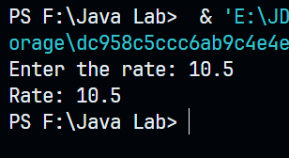

**Experiment 9**

**Aim: WAP in java to print speed of a bike using “final” variable.**

**Solution:**

public class SpeedOfBike {

final int speed;

public SpeedOfBike(int speed) {

this.speed = speed;

}

public void display() {

System.out.println("Speed of bike: " + speed + " km/hr");

}

public static void main(String[] args) {

SpeedOfBike bike = new SpeedOfBike(60);

bike.display();

}

}

**Output:**

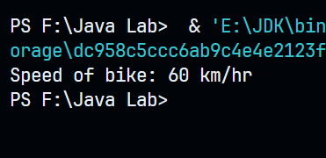

**Experiment 10**

**Aim: WAP a program in java using multilevel inheritance.**

**Solution:**

class A {

void display() {

System.out.println("Class A");

}

}

class B extends A {

void display() {

super.display();

System.out.println("Class B");

}

}

class C extends B {

void display() {

super.display();

System.out.println("Class C");

}

}

public class MultilevelInheritance {

public static void main(String[] args) {

C c = new C();

c.display();

}

}

**Output:**

